**Velammal College of Engineering and Technology, Madurai**

**An Autonomous Institution**

**Department of Computer Science and Engineering**

**21CS205 Object oriented programming lab**

Exercise No 2

Arrays and classes

Team 1

1. Develop the Internal mark calculation system based on the attendance percentage using Java. Get the student name, register number, total number of working days in the semester and Number of days present. Calculate attendance percentage of the students and award attendance mark based on the following condition.

Attendance percentage >=90 – 5 Marks

Attendance percentage >=80 and < 90 – 4 Marks

Attendance percentage >=75 and < 80 – 3 Marks

Attendance percentage <75 - 0 Marks

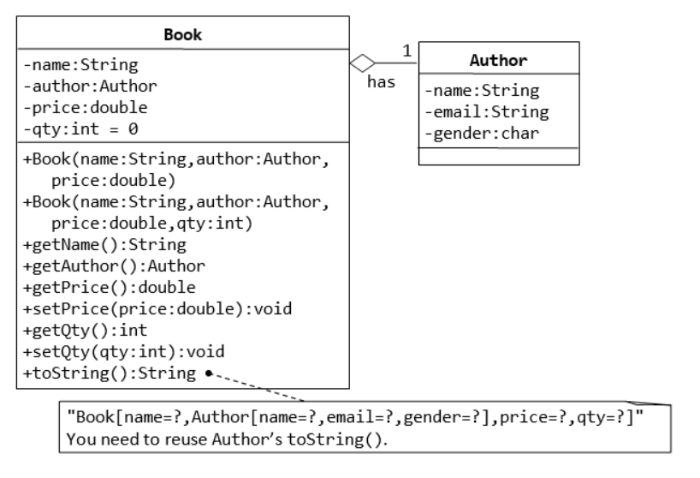

Team 2

1.

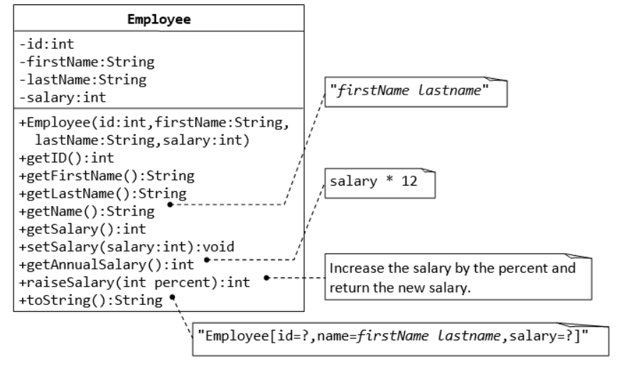

2. Develop a Java application to generate Electricity bill. Create a class with the following members: Consumer no., consumer name, previous month reading, current month reading, type of EB connection (i.e domestic or commercial). Compute the bill amount using the following tariff,

If the type of the EB connection is domestic, calculate the amount to be paid as follows:

* + - * First 100 units-Rs.1 per unit
      * 101-200 units - Rs. 2.50 per unit
      * 201 -500 units - Rs. 4 per unit
      * 501 units - Rs. 6 per unit

If the type of the EB connection is commercial, calculate the amount to be paid as follows:

* + - * First 100 units - Rs. 2 per unit
      * 101-200 units - Rs. 4.50 per unit
      * 201-500 units-Rs.6 per unit
      * 501 units - Rs. 7 per unit

Team 3

1.

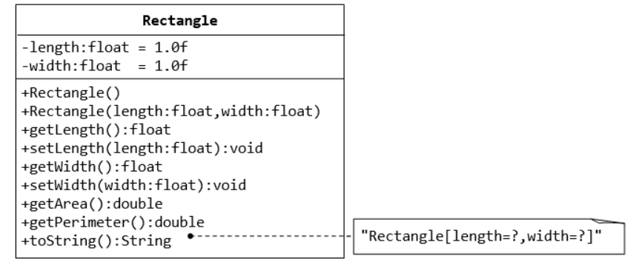

2.Define a class named **COMPLEX** for representing complex numbers that contains necessary data members and member functions. A complex number has the general form a + ib, where a is the real part and b is the imaginary part (i stands for imaginary). Include methods for all the four basic arithmetic operators.

Team 4

1.

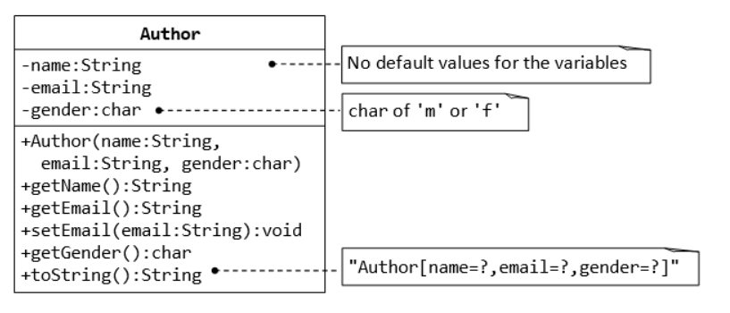

1. Develop a Java application to generate Electricity bill. Create a class with the following members Consumer no., consumer name, previous month reading, current month reading, type of EB connection (i.e domestic or commercial). Compute the bill amount using the following tariff.  
   If the type of the EB connection is domestic, calculate the amount to be paid as follows:

First 100 units – Rs. 2 per unit  
 101-200 units – Rs. 3.50 per unit  
 201 -500 units – Rs. 5 per unit  
> 501 units – Rs. 6 per unit

If the type of the EB connection is commercial, calculate the amount to be paid as follows:

First 100 units – Rs. 3 per unit  
 101-200 units – Rs. 5.50 per unit  
 201 -500 units – Rs. 7 per unit  
> 501 units – Rs. 8 per unit

Team5

1. Write a java program to perform the following functions using classes, objects, constructors and destructors where essential.

i)Get as input the marks of 5 students in 5 subjects

ii) Calculate the total and average

iii)Print the formatted results on the screen

2.

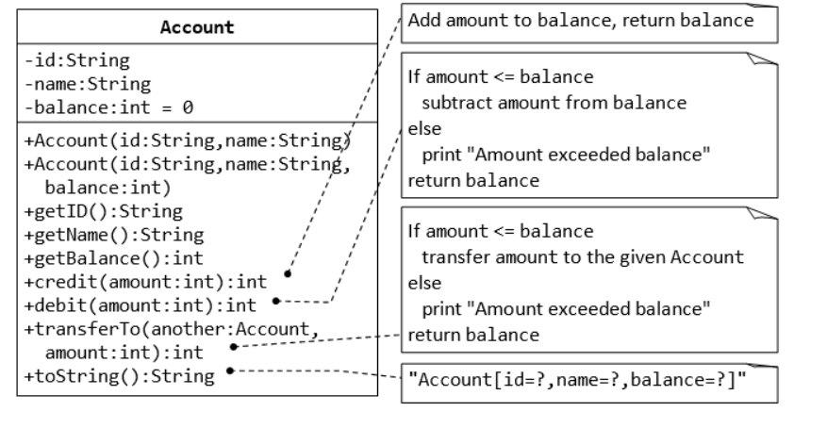

Team6

1.A class called **circle** is designed as shown in the following class diagram. It contains:

* Two private instance variables: radius (of the type double) and color (of the type String), with default value of 1.0 and "red", respectively.
* Two *overloaded* constructors - a *default* constructor with no argument, and a constructor which takes a double argument for radius.
* 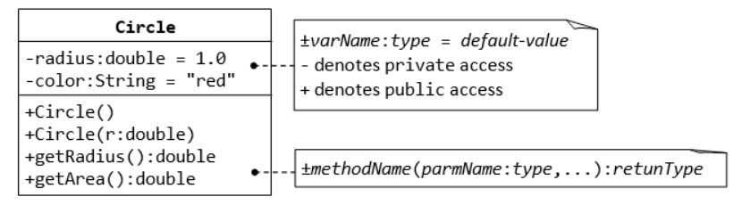Two public methods: getRadius() and getArea(), which return the radius and area of this instance, respectively’

1. Prepare Electricity bill using Java.

Create a class with the following member:

Consumer number, Consumer name, previous month reading, current month reading, type of EB connection.

Calculate the domestic connection bill amount using the following tariff:

First 100 units – Rs. 1.50 per unit

101-200 units –Rs. 3 per unit

201- 500 units – Rs. 4.50 per unit

>501 units – Rs. 7 per unit

Calculate the commercial connection bill amount using the following tariff:

First 100 units – Rs. 2.50 per unit

101-200 units –Rs. 5 per unit

201- 500 units – Rs. 6.50 per unit

>501 units – Rs. 9 per unit

Team7

1.

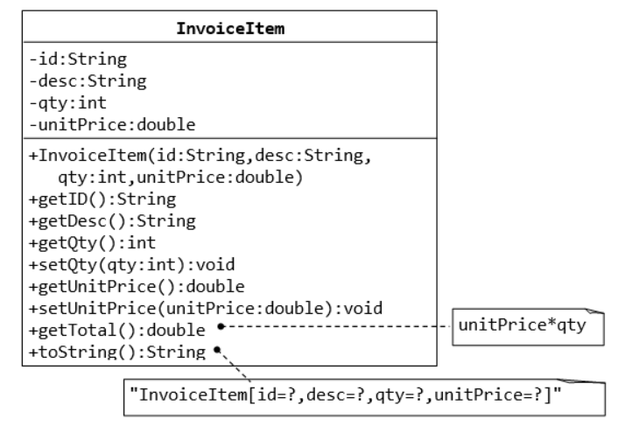

2. Write a Java program to read 5 subject marks of a student and calculate the total and grade. The grade system is as follows.

|  |  |  |
| --- | --- | --- |
| **Letter Grade** | **Grade Points** | **Marks Range** |
| O (Outstanding) | 10 | 91 – 100 |
| A+ (Excellent) | 9 | 81 – 90 |
| A (Very Good) | 8 | 71 – 80 |
| B+ (Good) | 7 | 61 – 70 |
| B (Average) | 6 | 50 – 60 |
| RA | 0 | < 50 |

Team 8

1. Car Owner Class

|  |
| --- |
| Owner |
| * Name :String * City:String * Profession:String |
| +Owner(Name:String, City:String,Profession:String)  +getName():String  +getCity():String  +getProfession():String  +toString():String |

|  |
| --- |
| Car |
| * Registration number:int * Colour:String * Number of seats:int * Brand:String * Model:int * Owner:Owner |
| Car(Registrationnumber:int,Colour:string,NumberOfseats:int, Brand:String, Model:int,Owner:Owner)  +getRegistrationnumber():int  +getColour():String  +getBrand():String  +getModel():int  +toString():String |

Create an array of five car objects and show the details of each car

2. create a class employee with the following attributes

(i) Name (ii)ID (iii) Age (iv) Designation(V) Department (vi) Salary.

Write Suitable constructor and method to display the details employee object.

In the main method create 5 employee objects and display the employee name and designation (i) Who belongs to CSE department (ii) whose salary is above 10000.